Q1:

1. Design a Webpage for online food delivery system using HTML and CSS.

HTML CODE:

<!DOCTYPE html>

<html>

<head>

    <title>Food</title>

    <link rel="stylesheet" href="q1_css.css">

</head>

<body>

    <div class="container">

        <div class="linke">

            <div>

                <a href="#" target="_blank">Login</a>

                <a href="#" target="_blank" id="temp_gap">Sign Up</a>

            </div>

        </div>

        <div class="text_on_pic">

            <div class="zmto">

                <img src="zm.avif" alt="food" class="image1" >

            </div>

            <br>

            <div id="moto">we serve the best food</div>

        </div>

        <div class="search-optns">

            <div class="search">

                <div><select> <option>Location</option></select></div>

                <div><input type="text" placeholder="Search for restaurant, cuisine or a dish" class="search-bar"></div>

            </div>

        </div>

    </div>

    <div id="below_pic">

        <span class="container1">

            <a href="#"><img src="food_main.jpg" alt="food" class="image2"  ></a>

            <p>Order Online</p>

        </span>>

        <span class="container1">

            <a href="#"><img src="meal.jpeg" alt="food" class="image2" ></a>

            <p>Go out for a meal</p>

        </span>>

        <span class="container1">

            <a href="#"><img src="clubs.jpeg" alt="food" class="image2" ></a>

            <p>Night life & clubs</p>

        </span>>

        <span class="container1">

            <a href="#"><img src="pro.jpeg" alt="food" class="image2" ></a>

            <p>Zomato Pro</p>

        </span>>

    </div>

</body>

</html>

CSS CODE:

* {

margin: 0;

padding: 0;

}

.container {

background: url(zmto.avif);

background-size: cover;

margin: 0;

padding: 0;

position: relative;

width: 100%;

height: 100vh;

overflow: hidden;

font-family: 'Arial', sans-serif;

display: inline-block;

}

.main_image {

width: 100%;

height: 75%;

object-fit: cover;

}

.text_on_pic {

top: 25%;

left: 50%;

color: rgb(237, 237, 237);

font-size: 90px;

font-weight: bold;

text-align: center;

}

#moto {

font-size: 45px;

}

#below_pic {

display: flex;

justify-content: space-evenly;

align-items: center;

width: 100%;

padding: 10px;

margin: 0 auto;

}

.container1 {

text-align: center;

color: rgb(0, 0, 0);

font-size: 25px;

font-weight: bold;

position: relative;

}

.text {

position: absolute;

top: 50%;

left: 50%;

transform: translate(-50%, -50%);

font-size: 24px;

}

.image2 {

width: 180px;

height: auto;

}

#pic {

height: 120px;

width: 100px;

}

.image {

width: 23%;

height: auto;

object-fit: cover;

}

#temp_gap {

margin-right: 20px;

}

.linke {

display: flex;

justify-content: right;

align-items: center;

height: 30px;

width: 100%;

padding: 10px;

margin: 0 auto;

color: rgb(255, 255, 255);

font-size: 20px;

font-weight: bold;

}

a {

text-decoration: none;

color: rgb(255, 255, 255);

margin-left: 20px;

font-size: 18px;

font-weight: bold;

}

.search-optns {

display: flex;

height: 200px;

justify-content: row;

justify-content: center;

}

.search {

width: 90%;

height: 50px;

max-width: 770px;

display: flex;

justify-content: center;

background-color: white;

border-radius: 5px;

}

.search select {

border: none;

background-color: white;

border-radius: 5px;

padding: 10px;

margin: 5px;

font-size: 20px;

}

.search-bar {

width: 600px;

border: none;

background-color: white;

border-radius: 5px;

padding: 10px;

margin: 5px;

font-size: 20px;

}

OUTPUT:

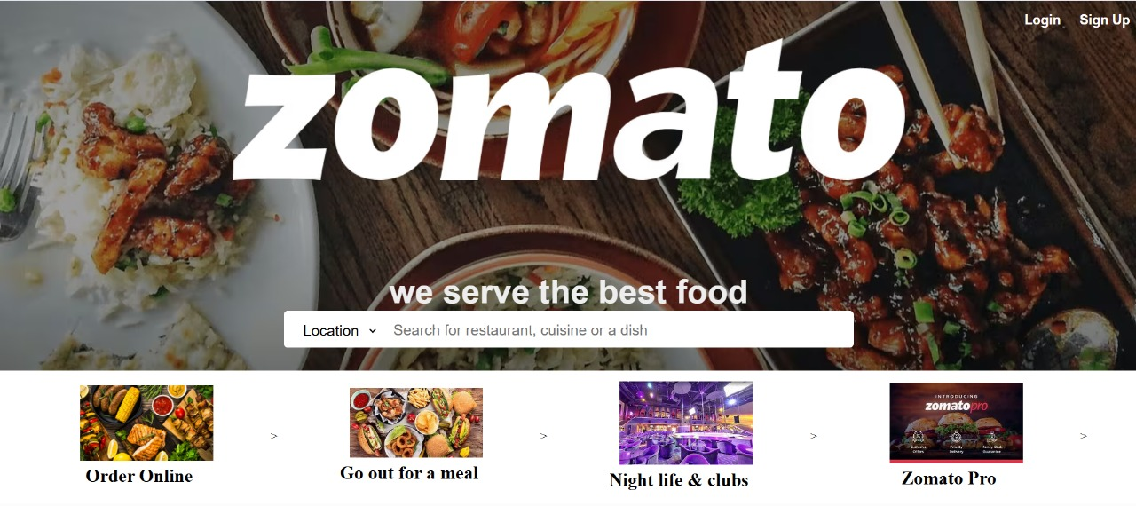

Q2:

2.Design a design college website using HTML and CSS.

HTML CODE:

<!DOCTYPE html>

<html lang="en">

<head>

    <meta charset="UTF-8">

    <meta name="viewport" content="width=device-width, initial-scale=1.0">

    <title>SVNIT Surat</title>

    <link rel="stylesheet" href="temp.css">

</head>

<body>

    <div class="head">

        <img src="logo_svnit.png" alt=".">

        <img src="name.png" alt=".">

        <img src="sardar.png" alt="." style="padding-right: 0%;">

    </div>

    <div class="nav">

        <div class="about"><select><option><h3>ABOUT US</h3></option></select></div>

        <div class="about"><select><option>ADMINISTRATION</option></select></div>

        <div class="about"><select><option>ACADEMIC</option></select></div>

        <div class="about"><select><option>DEPARTMENTS</option></select></div>

        <div class="about">STUDENT LIFE</div>

        <div class="about">RESEARCH & CONSULTANCY</div>

        <div class="about">CDC</div>

        <div class="about"><select><option>CENTRAL FACILITY</option></select></div>

        <div class="about"><select><option>CONTACT US</option></select></div>

    </div>

    <div class="content">

        <div class="sidebar" id="left">

            <div class="box"><a href="#" >Minutes of Meeting</a></div>

            <div class="box"><a href="#" >Memorandum of Understanding</a></div>

            <div class="box"><a href="#" >Ek bharat Shreshtha Bharat</a></div>

            <div class="box"><a href="#" >Achievements</a></div>

            <div class="box"><a href="#" >Central Library</a></div>

            <div class="box"><a href="#" >Alumni</a></div>

            <div class="box"><a href="#" >NIRF</a></div>

            <div class="box"><a href="#" >Career</a></div>

            <div class="box"><a href="#" >Vigilance Section</a></div>

            <div class="box"><a href="#" >RTI</a></div>

        </div>

        <div class="photo"><img src="main.png" alt=""></div>

        <div class="sidebar" id="right">

            <div class="box"><a href="#" >Samarth-eGov</a></div>

            <div class="box"><a href="#" >Chapters|Clubs|Society</a></div>

            <div class="box"><a href="#" >Newsletter</a></div>

            <div class="box"><a href="#" >Admission</a></div>

            <div class="box"><a href="#" >Scholarship</a></div>

            <div class="box"><a href="#" >Fee Structer</a></div>

            <div class="box"><a href="#" >Academic Calender</a></div>

            <div class="box"><a href="#" >JoSAA</a></div>

            <div class="box"><a href="#" >Hostel</a></div>

            <div class="box"><a href="#" >ncc</a></div>

        </div>

    </div>

</body>

</html>

CSS CODE:

.{

    margin: 0px;

    padding: 0px;

}

.head{

    height: 500px;

    width: 100%;

    justify-content: space-evenly;

    display: flex;

    flex-direction: row;

}

.head img{

    height: 100%;

    display: inline;

   ;

}

.nav{

    width: 100%;

    height: 250px;

    background-color: #0d2f5bf0;

    justify-content: space-evenly;

    align-items: center;

    display: flex;

}

.about{

    color: white;

    font-size: 50px;

}

.about select{

    background-color: #0d2f5bf0;

    font-size: 50px;

    color: white;

    border: none;

}

.content{

    width: 100%;

    height: 75vh;

    display: flex;

}

.sidebar{

    background-color: aqua;

    width: 15%;

    position: relative;

    height: 100%;

    margin-left: 5%;

    margin-top: 5%;

    border-radius: 5%;

}

#right{

    justify-content: right;

    margin-left: 5%;

}

.photo {

    width: 50%;

    display : inline-block;

    position: relative;

    justify-content: center;

    flex-wrap: wrap;

    align-content: center;

    margin-left: 5%;

}

.photo img{

    width: 100%;

}

.box{

    width: 100%;

    height: 9%;

    display: flex;

    border-bottom: white 10px solid;

    flex-direction: column;

    justify-content: center;

    align-items: center;

}

.box a{

    font-size: 4em;

    text-decoration: none;

}

OUTPUT:

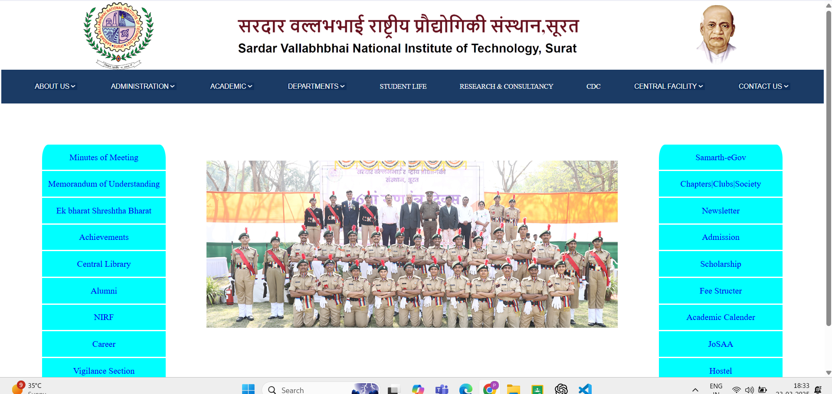

Q3:

3. Design Shopping Website Using HTML And CSS

HTML CODE:

<!DOCTYPE html>

<html lang="en">

<head>

    <meta charset="UTF-8">

    <meta name="viewport" content="width=device-width, initial-scale=1.0">

    <link rel="stylesheet" href="amazon_css.css">

    <link rel="stylesheet" href="https://cdnjs.cloudflare.com/ajax/libs/font-awesome/6.7.2/css/all.min.css">

    <title>amazon</title>

</head>

<body>

    <div class="nav">

        <div class="logoofamazon">

            <img src="logo1.jpg" alt="amazon logo">

        </div>

        <div class="location">

            <div class="loc_logo">

                <i class="fa-solid fa-location-dot fa-2xl"></i>

            </div>

            <div class="loc_dis">

                <div class="default">Deliver to</div>

                <div class="y_location"><input type="text" placeholder="Enter your location"></div>

            </div>

        </div>

        <div class="search" >

            <div class="cate"><select style="height: 100%; width: 75%;border: none;background-color: rgb(255, 255, 255);"> <option>All</option></select></div>

            <div class="find">

                <div class="search-bar" ><input type="text" style="height: 39px; width: 100%; font-size: large;border: none; " placeholder="Search Amazon.in" ></div>

                <div class="search-logo"><button style="border: none;"><img src="search_logo1.png" alt="search" style="height: 38px; width: 55px;align-items: right: ;;"></button></div>

            </div>

        </div>

        <div class="lang">

            <img src="flag.jpeg"  alt="flag">

            En

        </div>

        <div class="list">

            <div class="acc_list">

                <a href="#" style="width: 100%;height:100%;justify-content: center;" >Account & Lists</a>

            </div>

            <div class="return">

                <a href="#" style="width: 100%;height:100%;align-self: center;">Orders & Return</a>

            </div>

        </div>

        <div class="cart">

            <a href="#" ><img src="cart_ai.png" alt="cart" style="height: 100%;"></a>

        </div>

</div>

<div class="low">

    <div class="all"><a href="#" style="width: 100%;height:100%;justify-content: center;" >All</a></div>

    <div class="all"><a href="#" style="width: 100%;height:100%;justify-content: center;" >sell</a></div>

    <div class="all"><a href="#" style="width: 100%;height:100%;justify-content: center;" >Mobiles</a></div>

    <div class="all"><a href="#" style="width: 100%;height:100%;justify-content: center;" >Prime</a></div>

    <div class="all"><a href="#" style="width: 100%;height:100%;justify-content: center;" >Electronics</a></div>

    <div class="all"><a href="#" style="width: 100%;height:100%;justify-content: center;" >Amazon Pay</a></div>

    <div class="all"><a href="#" style="width: 100%;height:100%;justify-content: center;" >Home & Kitchen</a></div>

    <div class="all"><a href="#" style="width: 100%;height:100%;justify-content: center;" >Computers</a></div>

    <div class="all"><a href="#" style="width: 100%;height:100%;justify-content: center;" >Books</a></div>

    <div class="all"><a href="#" style="width: 100%;height:100%;justify-content: center;" >Car & Motorbike</a></div>

    <div class="all"><a href="#" style="width: 100%;height:100%;justify-content: center;" >Toys & Games</a></div>

</div>

<div class="main">

    <div class="card-container">

        <div class="card">

            <h3>Winter Wears|Ultimate Saver </h3>

            <div class="ver_photo">

                <img src="pic1_11.jpg" alt="shawl">

                <img src="pic1_2.jpg" alt="shawl">

                <img src="pic1_1.jpg" alt="shawl">

                <img src="pic1_4.jpg" alt="shawl">

            </div>

            <h4>winter sale is open.Get upto 20% off.</h4>

            <a href="#" style="text-decoration: none;">Explore</a>

        </div>

        <div class="card">

            <h3>Explore Artifacts|Bed Sheets </h3>

            <div class="hor_photo">

                <img src="artifacts.jpg" alt="shawl">

                <img src="artifacts1.jpg" alt="shawl">

                <img src="bedsheets.jpg" alt="shawl">

                <img src="light.jpg" alt="shawl">

            </div>

            <h4>Get upto 50% off.</h4>

            <a href="#" style="text-decoration: none;">Explore</a>        </div>

        <div class="card">

            <h3>Home Designer|Big sales </h3>

            <div class="hor_photo" id="deco">

                <img src="deco1.jpg" alt="shawl">

                <img src="deco2.jpg" alt="shawl">

                <img src="deco3.jpg" alt="shawl">

                <img src="deco4.jpg" alt="shawl">

            </div>

            <h4>winter sale is open.Get upto 20% on.</h4>

            <a href="#" style="text-decoration: none;">Explore</a>        </div>

        <div class="card">

            <h3>Life lessons source</h3>

            <div class="ver_photo" id="book">

                <img src="book0.webp" alt="shawl">

                <img src="book1.webp" alt="shawl">

                <img src="book2.webp" alt="shawl">

                <img src="book3.webp" alt="shawl">

            </div>

            <h4>Get upto 5% off.</h4>

            <a href="#" style="text-decoration: none;">Explore</a>

        </div>

    </div>

</div>

</body>

</html>

CSS CODE:

*{

    margin: 0px;

    padding: 0px;

    font-family: 'Arial', sans-serif;

}

.nav{

    display: flex;

    flex-direction: row;

    background-color: rgb(0, 0, 0);

    height:60px;

    justify-content: space-evenly;

}

.logoofamazon{

    height: 60px;

    width: 106.66px;

    display: flex;

}

.location{

    height: 60px;

    width: 200px;

    display: flex;

}

.loc_logo{

    color: white;

    display: flex;

    justify-content: center;

    align-items: center;

    margin-right: 5px;

}

.local_disc{

    display: flex;

    flex-direction: column;

    justify-content: space-evenly;

    align-items: center;

}

.default{

    margin-top: 10px;

    color: white;

}

.y_location{

    color: white;

    font-size: 12px;

}

.search{

    height: 40px;

    width: 500px;

    max-width: 700px;

    display: flex;

    border-radius: 10px;

    flex-direction: row;

    justify-self:center;

    align-self: center;

    background-color: white;

}

.cate{

    display: flex;

    flex-direction: row;

    position:relative;

    width: 12%;

    left: 7px;

    margin-right: 0px;

}

.find{

    position:relative;

    display: flex;

    right: 5px;

    width: 88%;

    flex-direction: row;

}

.search-bar{

    border: none;

    font-size: 20px;

    border-radius: 5px;

    margin-left: 0px;

    width: 100%;

    height: 100%;

}

.search-logo{

    display: flex;

    height: 100%;

    border: none;

    padding-left: 0px;

    align-self:flex-start;

}

.lang{

    position: relative;

    justify-content: center;

    display: flex;

    height: 15px;

    margin-left: 10px;

    padding-right: 2px;

    align-self: center;

    color: white;

    font: 100;

}

.list{

    display: flex;

    flex-direction: row;

    width: 200px;

    align-self: center;

    height: 100%;

    top: 100px;

    justify-items: center;

}

.acc_list a, .return a {

    position: relative;       /* Keeps the relative positioning */

    display: flex;            /* Flexbox for centering */

    justify-content: center;  /* Center horizontally */

    align-items: center;      /* Center vertically */

    width: 100%;

    height: 100%;

    text-decoration: none;    /* Keeps the links clean */

    color: white;             /* Text color */

}

.acc_list {

    width: 40%;

    padding-right:50px;

}

.return {

    width: 60%;

}

.low{

    display: flex;

    flex-direction: row;

    background-color: rgb(0, 31, 74);

    height:40px;

    justify-content: space-evenly;

}

.all a{

    position: relative;

    display: flex;

    justify-content: center;

    align-items: center;

    width: 100%;

    height: 100%;

    text-decoration: none;

    color: white;

}

/* .main{

    display: flex;

    flex-direction: row;

    justify-content: space-evenly;

    align-items: center;

    height: 100%;

} */

.main{

    margin: 0;

    padding: 0;

    display: flex;

    justify-content: space-evenly;

    height: 100vh;

    background-image: url('main.jpg'); /* Replace with your image */

    background-size: cover;

    background-position: center;

  }

.card-container{

    display: flex;

    flex-direction: row;

    flex-wrap: wrap;

    margin-top: 25%;

    justify-content: space-evenly;

    position: relative;

    width: 100%;

}

.card{

    display: flex;

    flex-direction: column;

    justify-content: space-evenly;

    align-items: center;

    width: 300px;

    height: 300px;

    background-color: white;

    position: relative;

    border-radius: 10px;

    box-shadow: 0 4px 8px 0 rgba(0, 0, 0, 0.2);

}

.hor_photo img{

    width: 50%;

    height: 50%;

}

.hor_photo{

    display: flex;

    flex-direction: row;

    justify-content: center;

    align-items: center;

    flex-wrap: wrap;

}

#deco img{

    width: 50%;

    height: 93.54px;

    padding-top: 0%;

}

#deco{

        display: flex;

        flex-direction: row;

        justify-content: center; /* Center content evenly */

        align-items: center; /* Align items properly */

        flex-wrap: wrap; /* Ensure items flow to the next row */

        gap: 0; /* Set gap to zero to avoid extra spacing */

}

#book img{

    width: 150px;

    height: 93.54px;

}

#book{

        display: flex;

        flex-direction: row;

        justify-content: center; /* Center content evenly */

        align-items: center; /* Align items properly */

        flex-wrap: wrap; /* Ensure items flow to the next row */

        gap: 0; /* Set gap to zero to avoid extra spacing */

}

OUTPUT:

